Name: Class:
Introduction
pH is used as a measure of the acidity or basicity of a solution, and is calculated using the following formula:
pH = –log₁₀[H₃O⁺]
Transposing this formula gives the formula:
[H₃O⁺] = 10^{–pH}
It is found that in aqueous solutions at 25°C:
[H₃O⁺][OH–] = 1 x 10^{–14}
Using this information we are able to calculate the pH of both acidic and basic solutions at 25°C.
No. | Question | Answer
Complete the table below by placing either an =, > or < symbol in the third column. (The first row has been completed as an example.) All statements refer to solutions at 25°C.

In acidic solutions | [H₃O⁺] | > | [OH–]
In basic solutions | [H₃O⁺] |  | 1 x 10^{–7} mol L⁻¹
In neutral solutions | [OH–] |  | 1 x 10^{–7} mol L⁻¹
In acidic solutions | [H₃O⁺] |  | 1 x 10^{–7} mol L⁻¹
In basic solutions | [H₃O⁺] |  | [OH–]
In acidic solutions | [OH–] |  | 1 x 10^{–7} mol L⁻¹
In basic solutions | [OH–] |  | 1 x 10^{–7} mol L⁻¹

 | Explain why, in pure water, the molar concentrations of H₃O⁺ and OH– are equal.
Rain from clean air at 25°C has a pH of approximately 6, but acid rain may have a pH as low as 3.
a With the aid of equations, explain why normal rainwater is acidic.
b How many times more acidic is acid rain with a pH of 3 than normal rainwater with a pH
of 6?
a Calculate the pH of:
i a 0.50 mol L⁻¹ HNO₃ solution
ii a 0.050 mol L⁻¹ Ba(OH)₂ solution.
b Give two reasons why two acid solutions of equal concentration could have different pH values.

Water undergoes self-ionisation according to the equation:
H₂O(l) + H₂O(l) ⇌ H₃O⁺(aq) + OH–(aq); ΔH = +57 kJ
As this is an equilibrium reaction, the equilibrium constant for the reaction will be temperature dependent, and hence the [H₃O⁺] of pure water will be temperature dependent. This, in turn, means that the pH of pure water will be temperature dependent, so it is possible for a neutral solution to have a pH other than 7! The following questions consider this concept.
No. | Question | Answer
 | Write the equilibrium law expression for the self-ionisation of water.
 | Given that the density of water is 1.0 g mL^{–1}, determine the molar concentration ([H₂O]) of water.
Given that the [H₂O] in pure water is so large, it may be considered to be constant, and therefore the equilibrium expression may be written as:
K_{w} = K × [H₂O]² = [H₃O⁺][OH–]
What effect will an increase in temperature have on:
a the value of K_{w}?
b the pH of pure water?
c the neutrality of pure water?
Explain your answers.

The change in pH of water with temperature is shown in the graph below. Use this graph to answer question 8.
<<Insert Figure 7.3>>
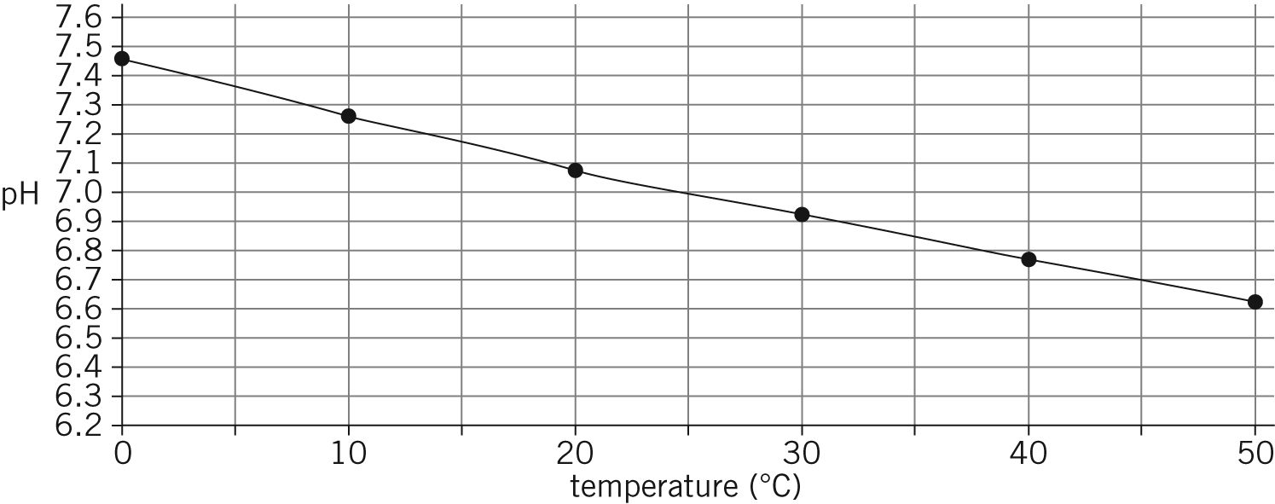

No. | Question | Answer
Determine:
a the [H₃O⁺] in pure water at 45°C
b the [OH–] in pure water at 35°C
c K_{w} for pure water at 18°C.

